WeatherPlaner
Weather and Activity planer according under Professor Nauroths examples.

API url = https://geocoding-api.open-meteo.com/v1/search

Outcome:
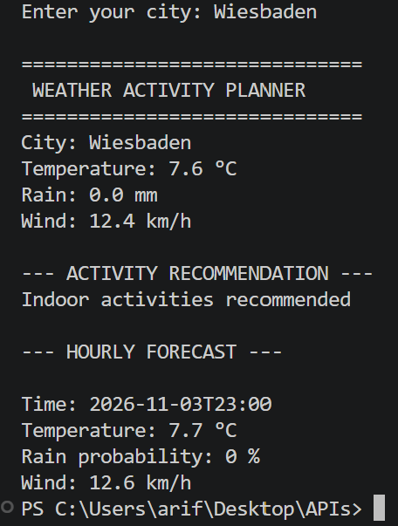
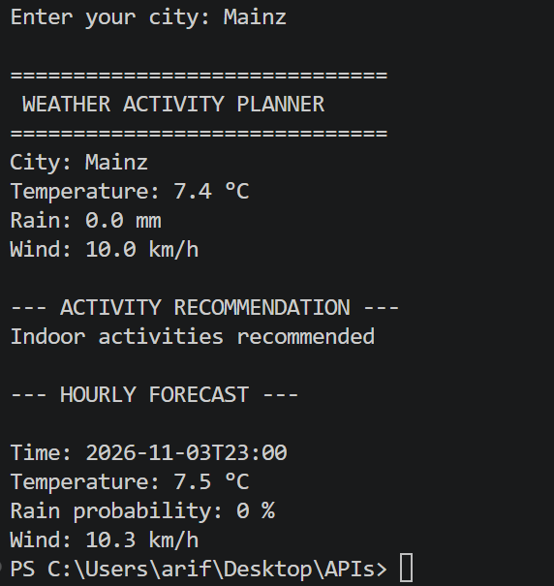

Food Nutrition Tracker
For those, who does sport, diet or simply want to see which nutritions are in theier meals.

API URL = https://api.nal.usda.gov/fdc/v1/foods/search

Outcome example:
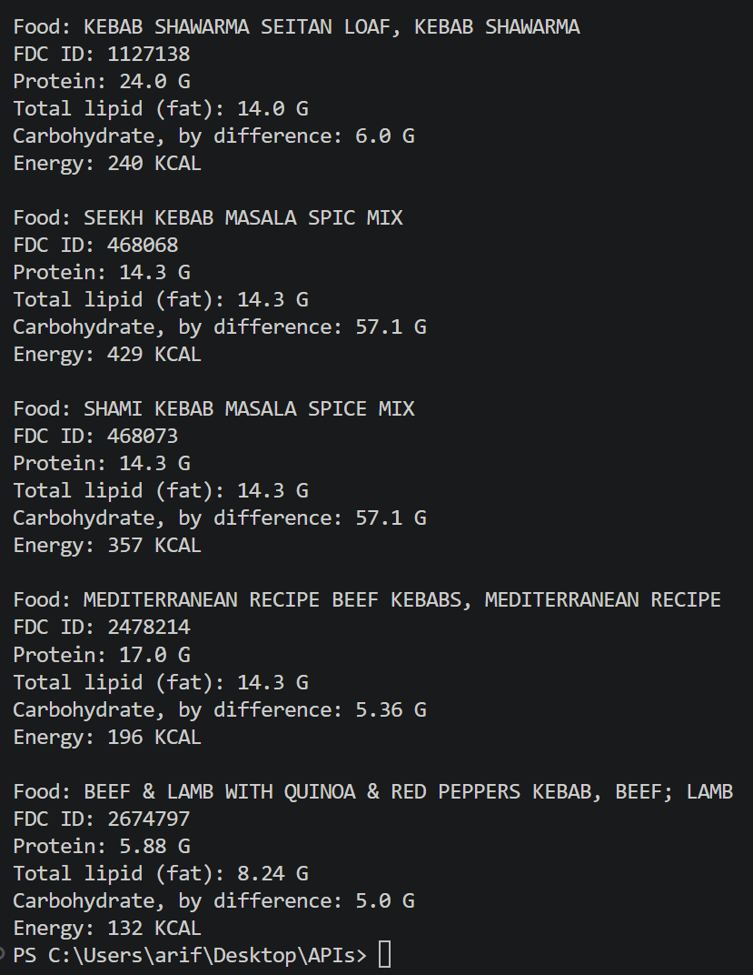

Eventplaner

To explore the events in a city, for tourist or locals who wants to go out, is a good API.

API URL: https://eventsimple.de/api/events
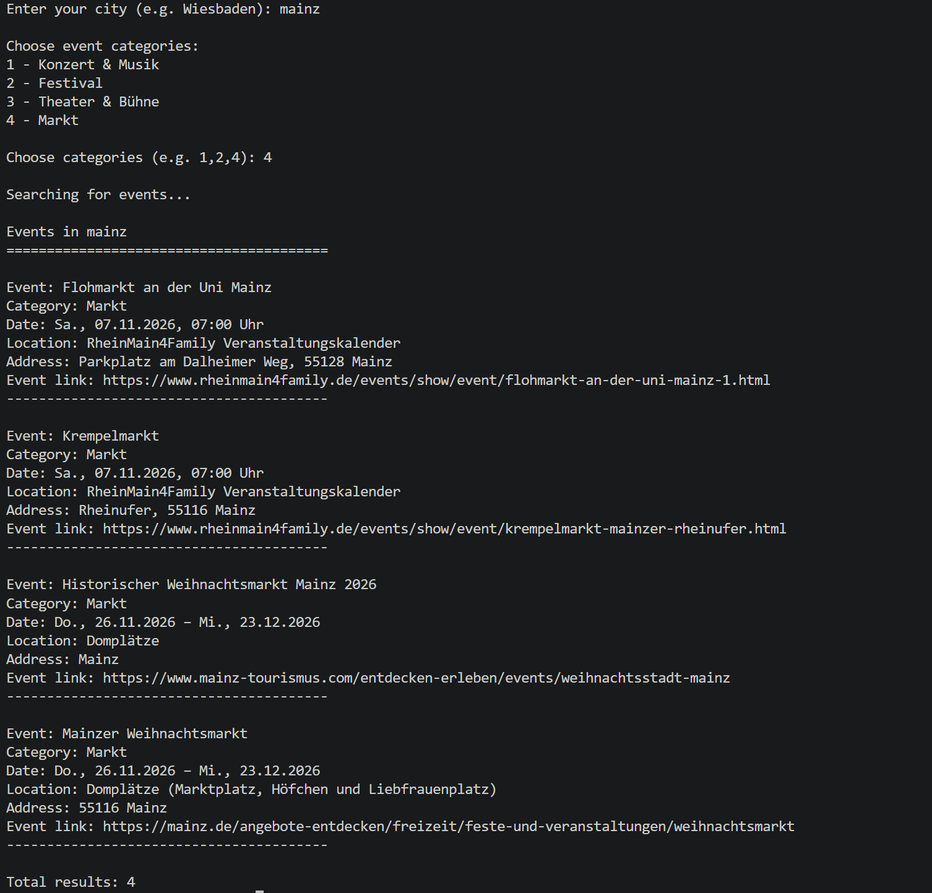

All three APIs are free to use, as long as not used in commercial purposes.

